**Distance Preferences**

**Consumption (tonnes/day) Cost**

In port At sea USD/tonne

Heavy fuel oil:   

Medium diesel oil:   

Cost per day:  (USD)

**Itinerary defaults**

Speed: 

Port days: 

Top of Form

Draft: 

 Avoid inshore traffic if possible

 Avoid rivers if possible

 Adjust speed and estimated

**Enabled Via Passages**

(Arctic) Bering Sea  (Arctic) Nort Sea Route  (Arctic) North-West Passage

Aland Archipelago  Antartica  Bonifacio Strait

Bosporus  Buran Channel

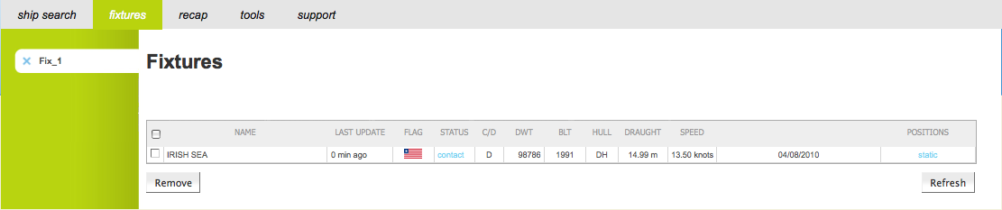

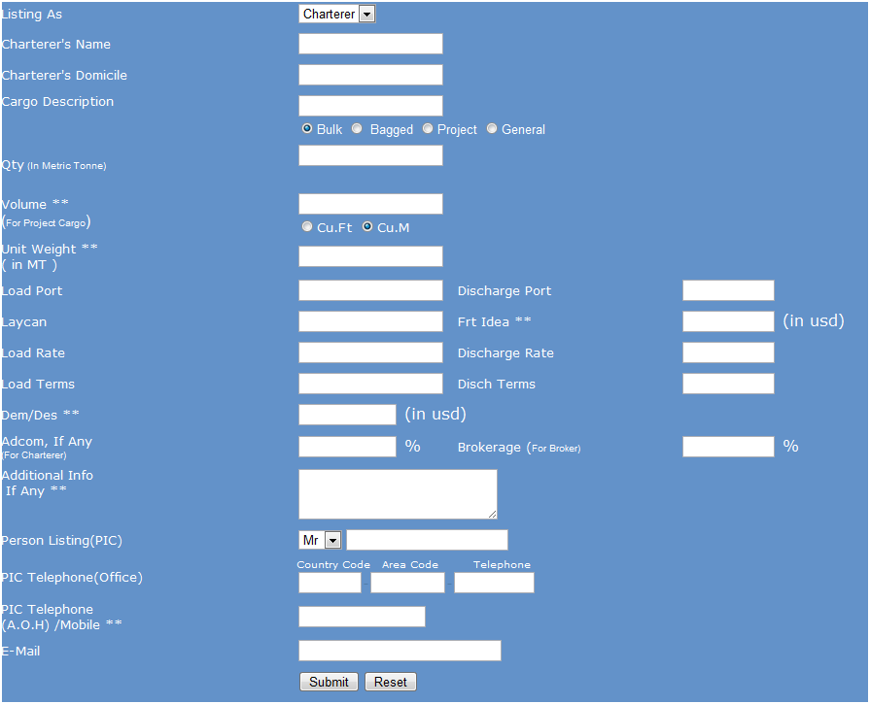 **Cargo Card Ship Card**

Top of Form



**Quick Look**

**Name:** <user defined / auto fill base on search criteria>

|  |  |  |  |  |  |  |  |  |  |  |
| --- | --- | --- | --- | --- | --- | --- | --- | --- | --- | --- |
| **Vessel** | **Nearness** | **Nearness**  **Rank** | **Fullness**  **Of Ship** | **Fullness**  **Rank** | **Age** | **Age Rank** | **Survey Alarm** | **Survey Rank** | **Flag** | **Total leg cost** |
|  |  |  |  |  |  |  |  |  |  |  |
|  |  |  |  |  |  |  |  |  |  |  |
|  |  |  |  |  |  |  |  |  |  |  |
|  |  |  |  |  |  |  |  |  |  |  |



**Cargo Details**

<Filled up details from Cargo Card – Fixture Management>



**Ship Details**

<Filled up details from Ship Card – Fixture Management>

Bottom of

**Check List**

<To be filled up by Calvin later on>



**Assumptions**

<Based on data from Veslink Quick Look>



**Notes**

<Related docs>